**Software Assembler:**

Here is the Demo of Software Assembler that converts the test-cases files (.asm) into Memory files (.mem) to be loaded to Instruction Memory directly.

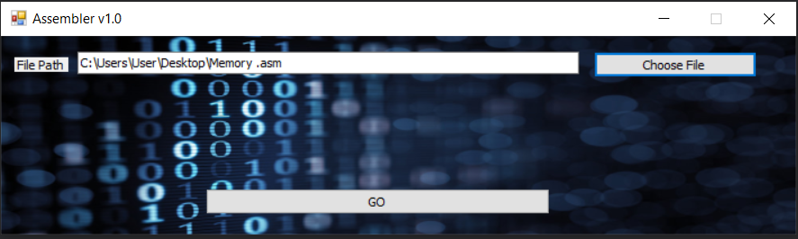**The Following Snapshots will show a demo of Converting an assembly file into a memory file:**

**Figure(1): Choosing .asm file needed to be converted**

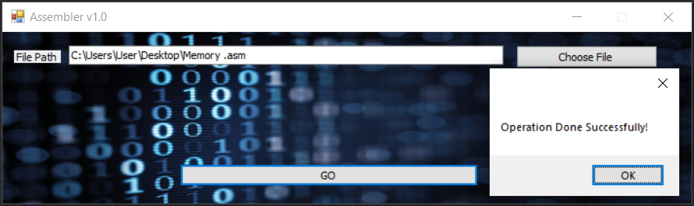**Figure (2): Pressing “GO” to start Converting it according to our Design**

**N.b: If there is error in the Format or the written instructions in the asm file, it will show an error message with the line number.**



**Figure (3): Now the File is Converted Successfully**

**We can now easily Load it to the Instruction Memory to run our test cases**

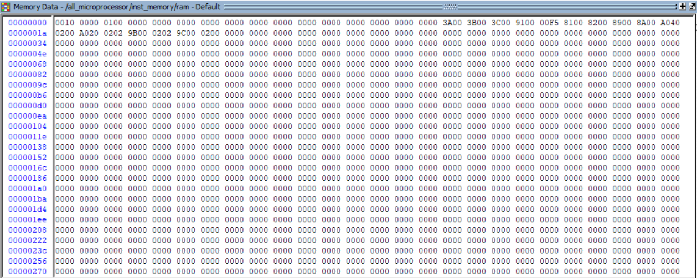

**Figure (4): A Snapshot from Instruction Memory after being imported with the .Mem File**